**DietPoint – www.dietpointed.com**

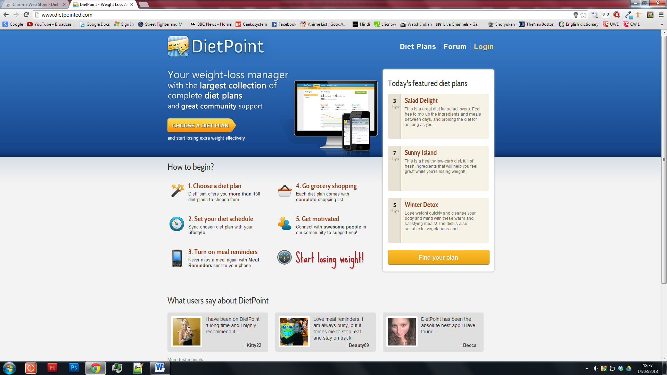

**Good Points**

* Gives users a featured diet plan – This could apply to our application by showing users the recommended meal of the day.
* The colour scheme is very neutral, making it more appealing to the user.
* Gives you instructions on how to use the website.
* Has a dedicated section which lists all the good review that the website’s current users have said.
* Offers a forum for other people to chat to and get motivated about dieting.
* Has supporting applications as well as websites.

**Bad points**

* The user needs to sign in to use the service.
* Offers too much content on one page – giving the user too much information to absorb.
* Is mainly based around one central theme.

**Tesco Food (Google Chrome application)**

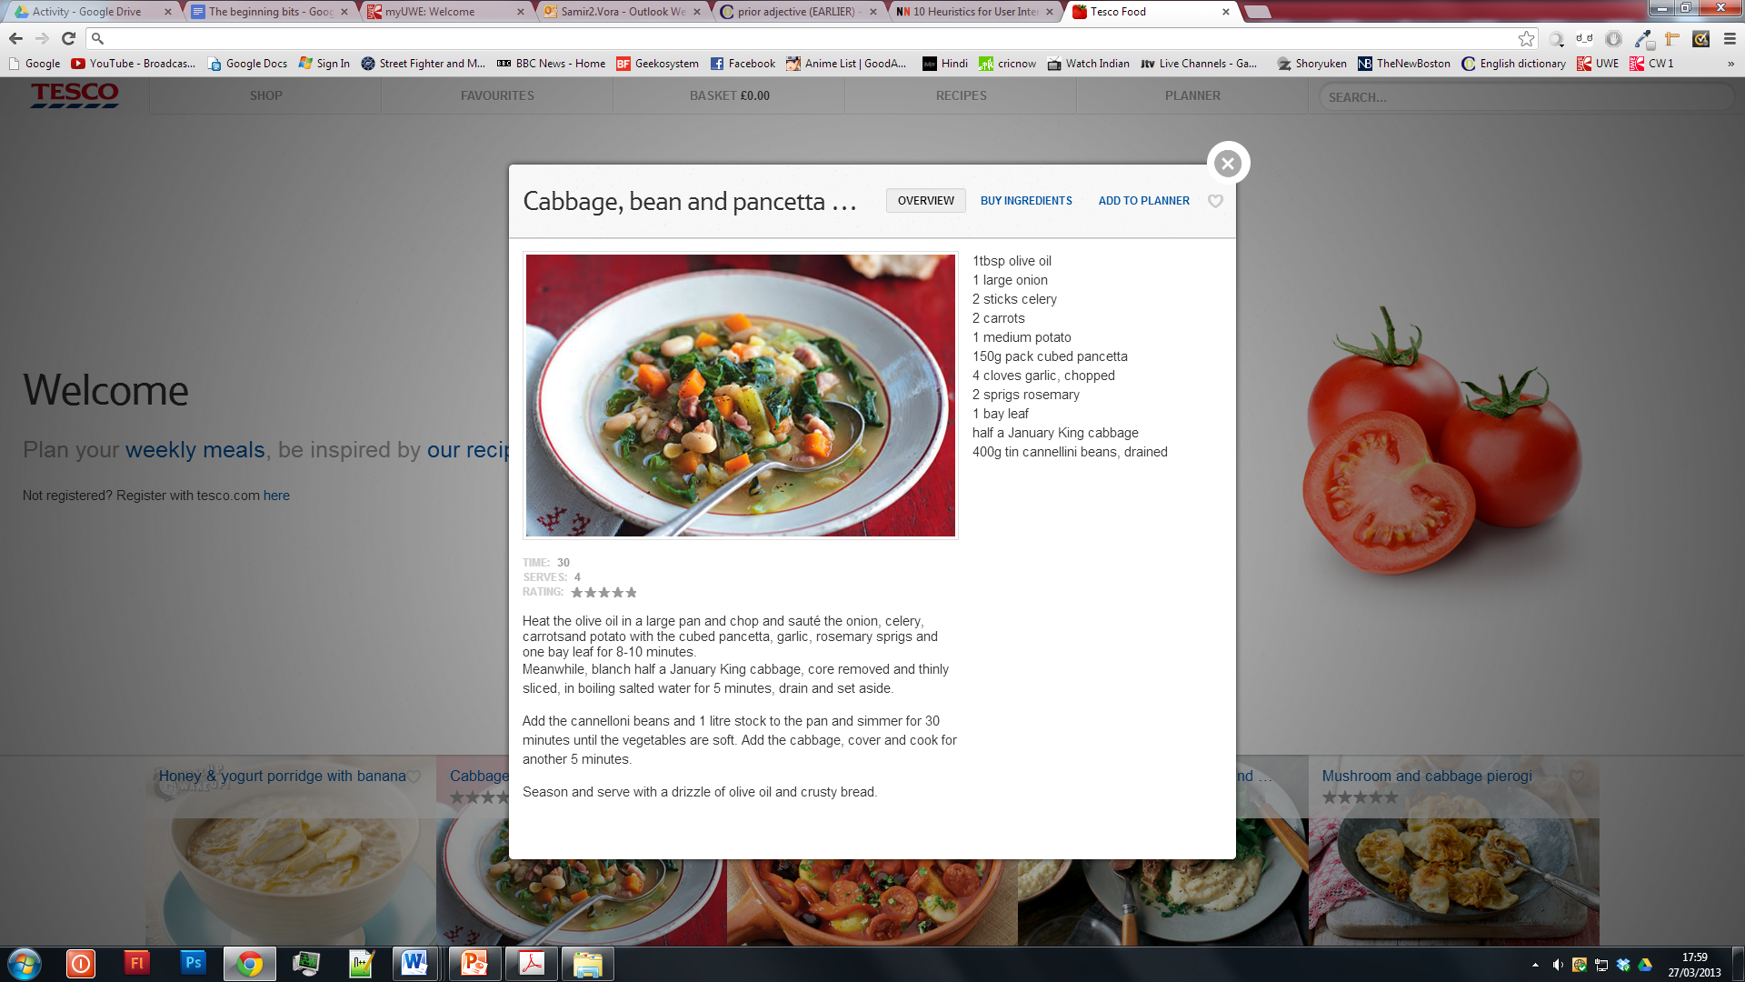

**Good Points**

* Has a rating system which allows the user to rate the meal
* Shows a high definition image of an appetising meal to hook the user in.
* Gives only the information about the meal that the user needs to know, and does not go too much into details.
* Offers the ingredients used within it.
* Allows the user to favourite the meal.
* The colour scheme is very neutral, thus allowing the images of the meal to stand out.
* Shows the user the total cost of all the items in their basket from the top navigation, meaning that the total price is always visible when the user is shopping for food.

**Bad points**

* It is only limited to showing recipes, and does not go beyond that.
* It presents too many recipes – gives too many options to the user.
* It has limited categories from which the user is able to sort their items.
* The user needs a Tesco account to use all of its features such as purchasing products.

**BBC Good Food - www.bbcgoodfood.com/chromeapp**

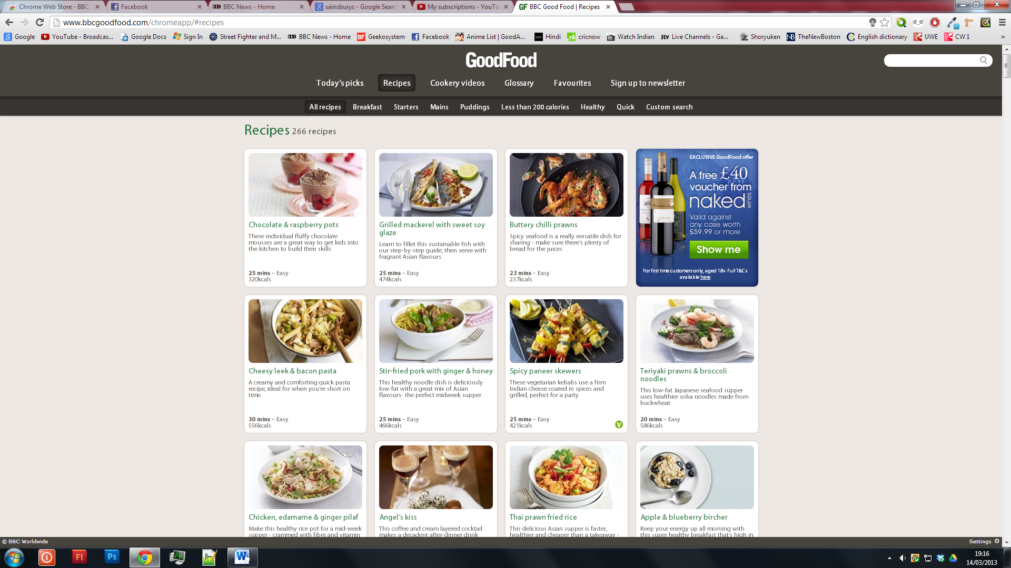

**Good Points**

* Gives users options to filter the recipes displayed by such categories as less than 200 calories, and healthy recipes.
* Presents a list of recipes to the user – This might also be thought of as a bad point because it gives too much information to the user.
* Gives a description about the recipe.
* Allows the user to favourite the recipes.
* Gives users an option like – “Todays Pick” – which offers them the recommended recipe of the day.
* Has videos to offer the user visual guidance.
* The colours are also neutral here, making the images stand out more.
* Allows the user to sign up to newsletters.

**Bad Points**

* Some of the images used as background are way too large.
* The settings option is hidden to the bottom right, and small text size.
* Has an advertisement of a wine.

**Recipes Notes – www.recipesnotes.com**

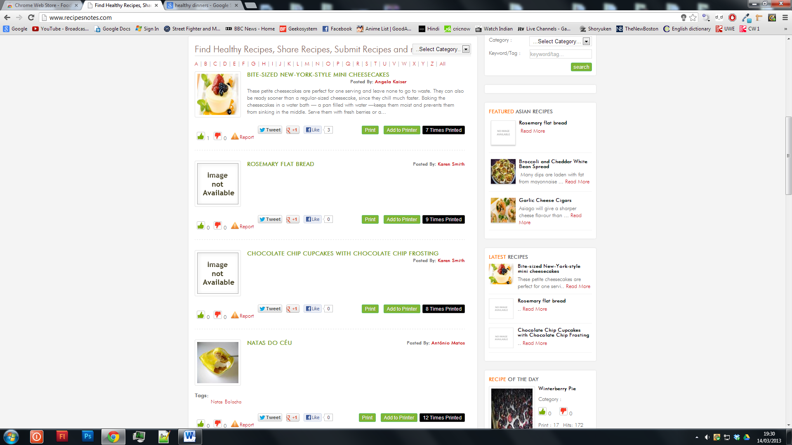

**Good points**

* Gives users the choice to search for recipes via an alphabetical order.
* Shows featured and latest recipes.
* Allows the user to save the recipes they find.
* “Most liked recipes”, “Most viewed”, “Most Rated” recipes.

**Bad Points**

* There are too many recipes, the user is overwhelmed.
* The information is not presented in a structured way on the homepage, it looks too untidy and not user friendly.
* The meal images are too small, and they tried to go fancy with JQuery.

**Vineo – www.vineohealth.com**

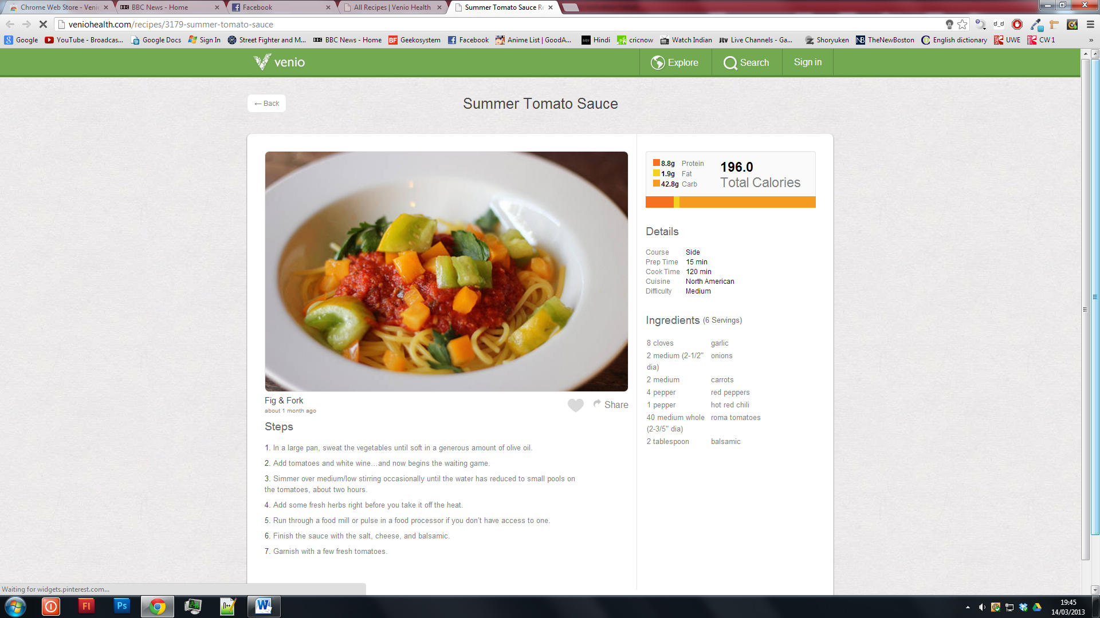

**Good Points**

* Offers users a visual indication of how much calorie, fat and protein is in the recipe.
* Allows users to favourite the recipe.
* Shows precise details of the ingredients in the recipe.
* Good neutral colours used and big image of the prepared meal from the recipe.

**Bad Points**

* It is very limited – only shows recipes and nothing else.
* Presents too many recipes to the user – needs to lessen some
* Limited sorting available – the user has to use the search functionality to search for recipes within certain criteria.